Phase 8 Summary
Periodic System Development + Final System Integration + System Robustness Validation + System Acceptance

Periodic Capture System Development
In Phase 7, the system completed the establishment of a trigger-based image capture system, achieving:
KEY EVENT → JPEG Capture → JPEG Transmission → PC Reception → AI Inference → MCU Feedback

The system had already acquired complete capabilities for data acquisition, transmission, and recognition.

However, the system still relied on manual button triggering. In essence, it remained an event-driven validation system. Each image capture required active user participation, preventing the system from continuously observing environmental changes or validating long-term operational stability under unattended conditions.

According to the overall project plan, the system development path was defined as:
Trigger-Based Capture System → Periodic Capture System

The objective was to provide the system with a certain degree of autonomous operation while maintaining controllable system complexity.

Based on the above analysis, the development of the Periodic Capture System (Cycle System) was formally initiated in this phase.

Architecture Migration
At the beginning of this phase, the original plan was to directly duplicate and modify the Trigger System project by removing the button-trigger logic and introducing a timer-based periodic scheduling mechanism.

However, during project migration, it was discovered that STM32CubeIDE exhibited abnormal behavior after project duplication, including incorrect debug configurations, abnormal ELF file references, and programming failures. Cross-validation indicated that these issues were more likely caused by defects in the development environment's project-copy mechanism rather than software logic or hardware faults.

Therefore, the development strategy was adjusted. Direct duplication of the original project was abandoned, and a newly created project was used as a stable baseline. Project configuration files were re-imported, and existing application modules were migrated one by one.

This adjustment not only avoided project-copying issues but also promoted the evolution of the system from a historically coupled structure toward a modular autonomous scheduling architecture.

Establishment of the TIM6 Periodic Scheduling Mechanism
To enable autonomous system operation, TIM6 was introduced in this phase as the periodic scheduling source.

The system operates using timer interrupts. Periodic events are generated at fixed intervals, while the main loop is responsible for launching the complete application workflow. During the initial stage, periodic LED toggling was used to verify timer operation, confirming that the periodic triggering mechanism had been successfully established.

The system execution model evolved from:
KEY EVENT → JPEG Capture → Image Transmission → AI Inference → Result Feedback
To:
PERIOD EVENT → JPEG Capture → Image Transmission → AI Inference → Result Feedback

TIM6 Configuration
  - TIM6 Parameters:
    - Timer Clock: 64 MHz
    - PSC: 63999
    - ARR: 9999
  - Corresponding Period:
    - 10 seconds

Final implementation:
  - TIM6 periodic interrupt
  - Periodic LED blinking
  - Periodic scheduling verification

For the first time, the system gained autonomous triggering capability and no longer relied on manual input.

Exposure of Scheduling Issues in the Periodic System
In the initial implementation of the periodic system, once TIM6 expired, a periodic capture flag was directly set, and the main loop would initiate a complete Session.

However, during actual operation, it was observed that a complete Session consisted of:
JPEG Capture → JPEG Parsing → Image Transmission → PC Reception → AI Inference → Session Cleanup

The entire execution process required a relatively long amount of time.

As a result, TIM6 could expire again and generate a new trigger request before the previous Session had finished.

This led to the following behavior:
TIM6 Expiration → New Pending Request Generated → Current Session Ends → Immediate Start of Next Session

The system effectively entered a state of continuous triggering without any cooling interval.

This issue caused:
- Frequent triggering of recovery mechanisms;
- Increased occurrence of CAPTURE_FAILED events;
- Frequent triggering of IMAGE_ABNORMAL detection;
- Frequent execution of both Soft Reset and PWDN recovery mechanisms.

Although the system did not crash, a clear recovery-storm phenomenon began to emerge.

Session-Based Scheduling Mechanism Reconstruction
To address the above issue, the scheduling logic of the periodic system was redesigned by introducing a Pending/Busy state-machine management mechanism.

The new scheduling process is as follows:
TIM6 Expiration → Set Pending Only → Main Loop Detects Pending → Start Session → Set Busy State → Suspend TIM6 → Execute Complete Session → Session Ends → Clear TIM6 Counter → Clear Busy State → Restart TIM6

Through this mechanism, the system transitioned from a model of "fixed-time task generation" to a model of "starting the next cooling period after Session completion."

This design prevents overlapping execution among multiple Sessions while ensuring that only one valid Session exists within the system at any given time.

After the scheduling mechanism was reconstructed, system testing was resumed.

Test results showed:
Stable periodic triggering behavior;
Normal recovery of Session intervals;
Elimination of continuous trigger events without cooling intervals;
Stable continuous image output;
Recovery mechanisms were no longer triggered excessively;
The system was capable of long-term autonomous operation.

More importantly, during the exposure of scheduling issues, the system unintentionally underwent a stress test of its recovery mechanisms.

Experimental results demonstrated that even under continuous abnormal conditions, the error detection mechanism, JPEG abnormality detection, Soft Reset/PWDN dual recovery mechanism, and Session Cleanup mechanism all continued to operate correctly and ultimately restored the system to normal operation.

LED Runtime Indication System Design
As the system transitioned from manual triggering to autonomous periodic operation, users could no longer directly determine whether the system was running through button interactions. Therefore, a more intuitive runtime status indication mechanism became necessary.

As the system transitioned from manual triggering to autonomous periodic operation, users could no longer directly determine whether the system was running through button interactions. Therefore, a more intuitive runtime status indication mechanism became necessary.

Subsequently, LED behavior was further integrated with the TIM6 scheduling logic, enabling it to simultaneously provide:
- Visualization of system survival status;
- Visualization of periodic trigger status;
- Visualization of Session execution status.

Through the runtime indicator LED, it became possible to quickly determine whether dead loops, task blocking, or scheduling anomalies had occurred during system operation, providing an important observation mechanism for subsequent long-duration testing.

IWDG Reset Mechanism Design
After the establishment of the periodic system, the system acquired the capability for long-term autonomous operation. Compared with the trigger-based system, the periodic system was more likely to expose latent software issues, such as unexpected dead loops, task blocking, or unknown state-machine failures.

To further enhance autonomous operation capability, the Independent Watchdog (IWDG) mechanism was introduced in this phase as the final layer of fault protection.

The IWDG operates using an independent hardware clock and continues counting even if the main program encounters abnormalities. During normal operation, the main loop periodically refreshes the watchdog according to a predefined strategy. If the system enters a dead loop or becomes unresponsive due to unknown reasons, it can no longer perform the refresh operation, and the IWDG automatically triggers a system reset after timeout.

After analysis, it was decided that watchdog refreshing should be based on a successful system safety loop, rather than simply on communication success.

Watchdog refresh allowed:
- Successful completion of TX_DONE / DONE_ACK;
- Successful handling of IMAGE_ABNORMAL;
- Successful handling of CAPTURE_FAILED.
Watchdog refresh not allowed:
- TRANSFER_FAILED.
Reason:
- TRANSFER_FAILED is more likely to represent:
  - Communication failure;
  - Handshake failure;
  - Transmission-path blockage;
  - Inability of the system to complete valid Sessions for an extended period.
These are precisely the scenarios in which the watchdog should take over recovery. Therefore, watchdog refreshing was intentionally disabled for this path.

Final configuration:
- LSI Clock ≈ 32kHz
- Prescaler = 256
- Reload = 3999
- Timeout = 32s
The watchdog overflow time is approximately 32 seconds.

Current system timing:
- TIM6 period ≈ 10s
- Session duration ≈ 15s
Total ≈ 25s, leaving a safety margin before watchdog timeout and preventing accidental triggering.

During testing, due to an unexpected issue, the watchdog refresh logic had not yet been implemented, causing the system to naturally trigger a watchdog reset.

This accidental experiment verified that:
- IWDG was configured correctly;
- The MCU could be reset successfully;
- The MCU could re-execute the initialization process after reset;
- The Camera Buffer cleanup mechanism executed after forced reset;
- The periodic system could restart successfully.
However, the communication module became locked and required manual termination.

This accidental experiment demonstrated that:
- The MCU side already possessed basic recovery capability;
- The PC side lacked a corresponding recovery mechanism.
After fixing the watchdog refresh logic, normal operation was restored and no further watchdog resets occurred during subsequent testing.

Nevertheless, the introduction of the watchdog provided hardware-level safety protection and established the final recovery capability for unexpected system faults, laying the foundation for future unattended long-duration operation experiments.

Establishment of the Feedback Mechanism
Following the previous development stages, the system had already completed the full processing chain of:
Camera Capture → JPEG Generation → UART Transmission → PC Reception → YOLO Inference

Meanwhile, the system had already acquired the capability of returning AI inference results back to the MCU.

However, one final component was still missing: user feedback.

Although the PC side was already capable of performing object detection and generating recognition results, users could not directly obtain the current detection status from the embedded device itself. The system was still at the stage where "the AI could perform recognition" and results could only be viewed through the communication module terminal on the PC side. The recognition results had not yet been reflected on the MCU side, and a complete closed-loop system had not yet been established.

Therefore, this phase focused on establishing an MCU-side feedback mechanism to achieve:
Image Capture → AI Inference → Result Return → Device Feedback

Ultimately forming a complete Perception–Decision–Feedback chain.

Establishment of the Feedback Mechanism for the Trigger-Based System
Before establishing the feedback mechanism, the first issue that needed to be resolved was:
When should the MCU obtain the AI inference result?

The initial design considered the following process:
MCU sends TX_DONE → PC returns DONE_ACK → MCU sends TYPE_REQ → PC returns TYPE_RESULT

However, after analyzing the Session lifecycle of the communication module, it was discovered that this design contained a potential issue.

After the PC sends DONE_ACK, the communication module has already terminated the current Session and returned to the WAIT_STANDBY state. At this point, the communication module only waits for the next STANDBY handshake and will no longer process TYPE_REQ requests.

Therefore, requesting AI results after DONE_ACK may cause the request to be lost.

Based on this analysis, the result acquisition procedure was redesigned as:
JPEG Transmission Complete → MCU sends TYPE_REQ → PC returns TYPE_RESULT → MCU updates feedback state → MCU sends TX_DONE → PC returns DONE_ACK → Session End

Through this modification, AI result acquisition was formally incorporated into the current Session lifecycle, enabling stable result feedback without requiring changes to the overall communication module architecture.

LED Feedback Design for the Trigger-Based System
The initial design adopted the following logic:
Default Green LED → Red LED ON when an insect is detected → Green LED restored during the next detection cycle

However, further experimentation revealed an obvious semantic conflict.

Under this design, the green LED simultaneously represented:
- Default system state;
- Waiting-for-detection state;
- NO-result state.

As a result, users could not accurately determine whether the system was currently waiting for detection or whether the previous detection result had been NO.

After reorganizing the feedback semantics, the final design was determined as:
- Busy → LEDs OFF
- NO → Green LED ON
- YES → Red LED ON

Where:
- Busy indicates that the system is performing image acquisition, image transmission, and AI inference;
- NO indicates that no insect is currently detected;
- YES indicates that an insect is currently detected.

This design ensures a one-to-one correspondence between system states and feedback behavior, eliminating ambiguity caused by overlapping meanings.

Establishment of the Feedback Mechanism for the Periodic Trigger System
After successful validation of the feedback mechanism on the trigger-based system, the mechanism was migrated to the periodic trigger system.

However, significant differences exist between the trigger-based system and the periodic trigger system.

According to the MCU feedback mechanism established in the previous trigger-based system:
- Busy: System operating
- NO: No insect detected
- YES: Insect detected
Corresponding LED behavior:
- Busy → LEDs OFF
- NO → Green LED ON
- YES → Red LED ON

However, during the development of the periodic trigger system, the green LED had already been assigned the responsibility of indicating system survival status and periodic Session execution status. Therefore, the previous design of "NO → Green LED" could no longer be used.

After redesign, the final scheme was determined as:
- Green LED → Periodic system status indication
- Red LED → AI detection result indication
Specific logic:
- YES → Red LED ON
- NO → Red LED OFF

Through this modification, system operating status and AI detection results were effectively separated, avoiding semantic confusion within the periodic system.

Evaluation of the Buzzer Solution
After completing the LED feedback mechanism, the system was already capable of providing visual feedback to users regarding detection results.

However, LED feedback still exhibited several limitations during practical use:
- Users must continuously observe the development board;
- Visibility is limited at longer distances;
- Detection result changes may be missed during periodic operation.

Therefore, the feasibility of integrating the onboard buzzer was evaluated during this phase.

Hardware analysis revealed that both the onboard buzzer and the camera PWDN control were managed through the PCF8574 I/O expander.

This architecture implies that directly controlling the buzzer through register writes could inadvertently modify the camera PWDN state, potentially affecting camera operation.

To address this issue, the PCF8574 control method was redesigned to support bit-level manipulation, allowing only the target control bit to be modified while preserving all other states unchanged, thereby eliminating resource conflicts between the buzzer and the camera.

According to the hardware schematic:
PCF8574 P0 → BEEP → 8550 → Onboard Buzzer

Theoretical analysis indicated:
P0 = 0: Buzzer ON
P0 = 1: Buzzer OFF

To avoid introducing unknown risks into the main project, an independent test project was first created for verification.

Experiment:
- Toggle P0 high and low levels;
- Observe buzzer behavior.
Results:
- P0 = 0: Buzzer sounds normally;
- P0 = 1: Buzzer turns off.

Establishment of the Buzzer Feedback Mechanism

Development of the Buzzer Feedback Mechanism for the Trigger-Based System
The trigger-based system was first modified by introducing:
- g_pcf8574_state
as a shadow-state cache for the PCF8574.

Additionally:
- BSP_PCF8574_CameraPowerOn()
- BSP_PCF8574_CameraPowerDown()
were added so that only P2 is modified instead of overwriting the entire PCF8574 state.

After the modifications, validation was performed for:
- Camera initialization;
- JPEG acquisition;
- Error detection and recovery mechanisms;
- Image transmission.

All functions operated normally, indicating that the PCF8574 shared-control issue had been successfully resolved and that future buzzer integration would not interfere with camera control.

After completing the preliminary verification, the buzzer feedback mechanism was integrated into the trigger-based system.

A dedicated:
- feedback.h/c
module was established to unify LED and buzzer feedback management.

Implemented behavior:
- YES → Red LED ON + Short buzzer beep;
- NO → Green LED ON;
- BUSY → No feedback.
Additionally:
- ENABLE_BUZZER macro switch
was introduced to allow the buzzer to be disabled in experimental environments and avoid noise during long-term operation.

Experimental results:
- Feedback logic operated correctly;
- Buzzer functioned normally;
- Camera operation was unaffected.

Migration of the Buzzer Feedback Mechanism to the Periodic Trigger System
After successful validation on the trigger-based system, the same design and logic were migrated to the periodic trigger system.

The buzzer feedback logic remained identical:
- YES → Red LED ON + Short buzzer beep;
- NO → Red LED OFF.
At the same time, all feedback functions were migrated into the newly established feedback.h/c module.

Since the green LED remained responsible for system operation indication, it continued to reside within the Trigger_Event.h/c module.

As a result, system responsibilities became more clearly defined and the overall architecture became more organized, providing a solid foundation for future expansion and long-term maintenance.

Experimental results:
- Feedback logic operated correctly;
- Buzzer functioned normally;
- Camera operation remained unaffected.

Conclusion
This phase successfully established the device-side feedback mechanism, upgrading the system from one in which "the AI can perform recognition" to one in which "users can directly obtain recognition results."

The system ultimately formed the following complete closed loop:
Camera Capture → JPEG Generation → UART Transmission → YOLO Inference → MCU Result Acquisition → LED Feedback → Buzzer Feedback

At this point, the system possesses complete perception, decision-making, and feedback capabilities.

For the first time, the Embedded AI Insect Detection System established a complete human–machine interaction chain, laying the foundation for subsequent system acceptance testing and long-term operational validation.

Image Capture Performance and Working Environment Optimization
With the development of the periodic capture system and feedback mechanisms, the system gradually acquired the capability for long-term autonomous operation.

At this stage, the development focus began to shift from "whether the system can successfully capture images" to "whether the system can consistently obtain high-quality images."

Since the performance of an embedded vision system depends not only on the AI model itself, but also on factors such as the camera working environment, lighting conditions, target distance, and mechanical structure, this phase focused on evaluating the actual imaging performance of the OV2640 and establishing a standardized operating environment.

Structured Camera Installation
During early experiments, the camera was connected to the development board using 20 cm Dupont wires.

Although this configuration was sufficient for basic functional verification, limitations in the mechanical structure gradually became apparent during real-target experiments.

In particular, when the camera was positioned downward for image capture, the limited cable length made it difficult to construct a stable fixed imaging platform, restricting subsequent insect specimen experiments.

Therefore, the camera connection cable was upgraded to a 40 cm Dupont wire.

After the upgrade, the camera could be positioned independently of the development board, creating favorable conditions for the construction of a fixed workstation. At the same time, the experiment verified that image acquisition and JPEG generation remained stable even under longer connection distances.

Exposure Performance Analysis
After completing the hardware upgrade, multiple image acquisition experiments were conducted.

During testing, it was observed that when high-brightness backgrounds such as a white tabletop were used, the OV2640 tended to exhibit:
- Overall image whitening;
- Overexposure in highlight regions;
- Reduced contrast;
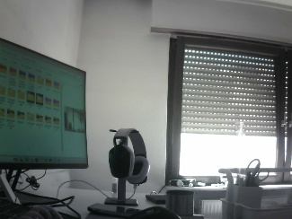
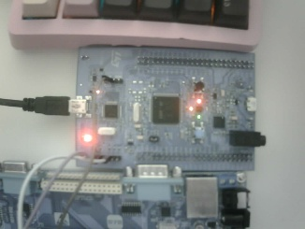
- Loss of image details.
Initially, the issue was suspected to originate from:
- Lens contamination;
- Signal degradation caused by the longer Dupont cable;
- JPEG transmission abnormalities.
However, after debugging and multiple comparative experiments, it was found that the phenomenon could be reproduced consistently. Therefore, communication-related factors were excluded.

Further analysis suggested that the issue was more likely related to the convergence behavior of the OV2640 Auto Exposure (AE) mechanism under large-area bright background conditions.

Subsequently, the imaging targets were changed to low-reflectivity scenes such as black leather and dark mesh fabrics.

Experimental results showed:
- Significant recovery of black levels;
- Richer texture details;
- Suppressed highlight regions;
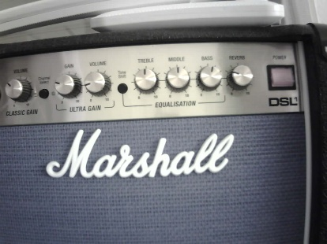
- Consistent image appearance across multiple frames.
Based on these observations, it was concluded that the current system is more suitable for operation under:
- Dark backgrounds;
- Stable lighting conditions;
- Low-reflectivity environments.

Camera Focus Adjustment Experiments
Following the exposure analysis, mechanical focus-adjustment experiments were carried out.

By continuously adjusting the focal distance and comparing JPEG image quality, it was ultimately determined that the optimal working distance for close-range image acquisition is approximately 30 cm.

At this distance:
- Image details are the richest;
- Insect edges appear the sharpest;
- JPEG information content is highest;



- AI detection results are the most stable.
Therefore, all subsequent experiments adopted 30 cm as the standard operating distance.

Construction of a Fixed Test Platform
To facilitate long-term operation testing, reduce human interference, and establish standardized operating conditions, a simple fixed test platform was constructed using a robotic arm and gripper that had previously been used during undergraduate studies.

The robotic arm was not powered and served only as a geometric support structure, forming the following configuration:
Camera → Support Beam → Sample Area
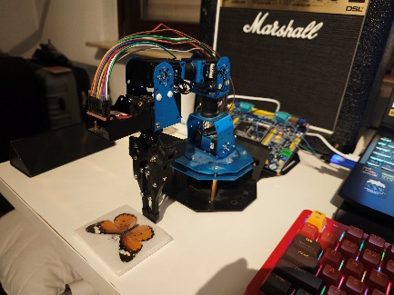
This arrangement achieved:
- Fixed camera height;
- Fixed camera angle;
- Fixed sample position.

Effectively reducing the influence of:
- Handheld vibration;
- Distance variation;
- Angle variation;
on experimental results.

Image Quality Improvement
During practical testing after the focus-adjustment experiments, image acquisition was primarily performed by hand-held operation.

At that time, normal JPEG file sizes were observed to be approximately:
35 KB – 43 KB
Initially, this range was considered representative of normal system operation.

Since the image abnormality threshold established in the previous phase was 40 KB, false abnormal detections frequently occurred. Consequently, the image abnormality threshold was adjusted to 30 KB.

However, after the fixed workstation was established, further testing revealed that normal JPEG sizes increased significantly to:
59 KB – 80 KB
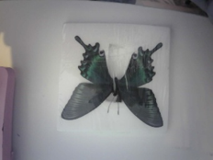
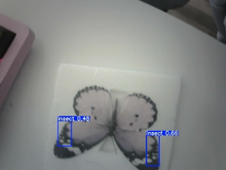
while image quality also improved noticeably.
68kb
60kb

Analysis suggested that the smaller JPEG sizes observed during earlier experiments were not solely caused by imaging distance. More likely causes included:
- Handheld vibration;
- Frequent composition changes;
- Focus drift;
- Unstable lighting conditions.

The fixed workstation effectively eliminated these factors, enabling more stable image acquisition and higher information content.

This result demonstrates that improvements in the working environment can contribute as much to image quality enhancement as camera parameter optimization itself.

Based on all experimental results, the final standardized operating conditions were determined as follows:
- Camera working distance: 30 cm;
- Black matte background (recommended);
- Stable lighting conditions;
- Fixed workstation structure;
- Relative static positioning between camera and target.
Under these conditions, the system is capable of continuously obtaining stable, high-quality JPEG images and providing reliable input for AI detection.

Evaluation of the Image Abnormality Detection Threshold
After the improvement of image quality, the previously established capture_len abnormality detection threshold was re-evaluated.

The reason for this reassessment was that the improved working environment resulted in normal JPEG sizes significantly larger than those observed during earlier experiments.

In theory, the abnormality detection threshold could have been increased further.

However, subsequent long-term operation tests demonstrated that the existing 30 KB threshold was already capable of effectively identifying most abnormal images while producing no false detections.

Furthermore, the system had already successfully passed both the 30-minute and 1-hour continuous error-injection tests while maintaining stable operation.

Based on the principle of avoiding unnecessary modification of critical parameters when the system is already operating stably, the existing threshold configuration was retained without further adjustment.

Conclusion
Through hardware upgrades, exposure analysis, focus-adjustment experiments, and the construction of a fixed workstation, a standardized operating environment was established during this phase.

Experimental results demonstrated that image quality is influenced not only by the camera itself, but also by factors including imaging distance, background color, lighting conditions, and mechanical support structures.

The final recommended operating configuration is:
30 cm Working Distance + Black Matte Background (Optional but Recommended) + Fixed Workstation + Stable Lighting

This environment significantly improves image quality while also providing a stable and reliable input foundation for subsequent AI capability evaluation and system acceptance testing.

AI Detection Capability and System Boundary Analysis
At this stage, the system had already acquired the capability to obtain high-quality JPEG images. Consequently, the development focus shifted from "whether images can be acquired reliably" to "whether the AI can reliably perform real insect detection."

Although YOLO model training had been completed during Phase 1, and offline validation had been performed using insect images collected from public datasets and online sources, previous experiments primarily relied on publicly available images rather than real insect targets.

Real Specimen Experiments
After obtaining insect specimens, experiments were first conducted using the trigger-based capture system.

The experimental subjects included:
- Dark blue butterfly specimen;
- White butterfly specimen.

During the experiments, the system executed the complete workflow:
Camera Capture → JPEG Generation → UART Transmission → PC Reception → YOLO Inference

Experimental results demonstrated that real insect targets could be detected reliably.

Multiple rounds of testing consistently produced:
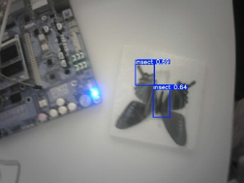
YES
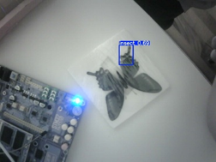
This indicates that the current system already possesses real insect detection capability. For the first time, the Embedded AI Insect Detection System successfully completed validation using real targets.

To further evaluate model performance under unfavorable conditions, additional experiments were conducted using light-colored targets.

The testing environment consisted of:
- White tabletop background;
- Light-colored butterfly specimen.

This scenario simultaneously introduced:
- Low-contrast targets;
- High-brightness background conditions.
These two factors represent relatively extreme testing conditions for the current system.

However, the results showed that:
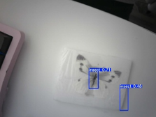
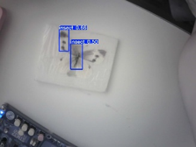
The AI still consistently produced YES.

This indicates that the current model retains a certain level of detection capability even for low-contrast insect targets.

Multi-Sample Testing
Following the completion of the periodic trigger system and the upgrades to both hardware and operating environment, further testing was performed using different specimens.

The following samples were evaluated:
- Yellow swallowtail butterfly;
- White/light-yellow butterfly;
- Dark blue butterfly;
- Black-and-white striped butterfly.
Experimental results revealed significant performance differences among different samples.

Specifically:
- Yellow swallowtail butterfly → Stable performance;
- White/light-yellow butterfly → Good performance;
- Dark blue butterfly → Reduced detection rate;
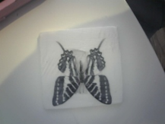
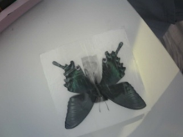
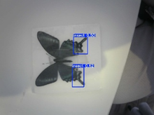
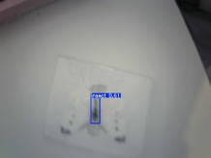
- Black-and-white striped butterfly → Frequent missed detections.
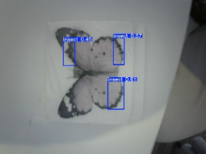
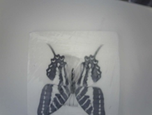
Initially, these differences were suspected to be related to:
- The periodic state machine;
- AI result polling;
- Continuous camera operation.

To investigate further, single-sample validation experiments were conducted under identical operating conditions. Ten photographs were captured for each specimen and compared.

First, continuous testing was performed using the yellow swallowtail butterfly.

Results were stable:
- 10 photographs;
- 10 successful detections;
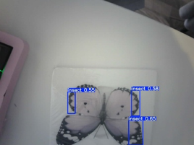
- All outputs were YES.
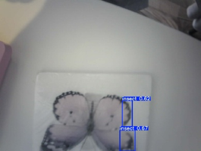
Subsequently, continuous testing was performed using the dark blue butterfly and the black-and-white striped butterfly.

Experimental results showed that missed detections still occurred frequently despite normal image quality:
- Dark blue butterfly: 3 successful detections out of 10 photographs;
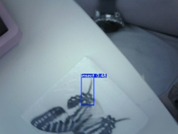
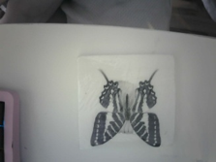
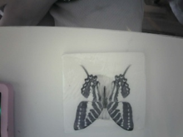
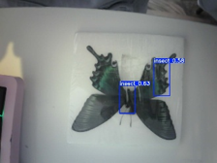
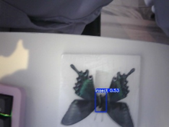
- Black-and-white striped butterfly: only 1 successful detection out of 10 photographs.
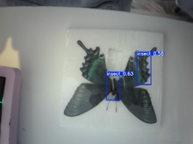
Therefore, the following engineering-related causes were excluded:
- Camera abnormalities;
- JPEG transmission abnormalities;
- Periodic system logic errors.

It was ultimately confirmed that the differences in recognition performance originated primarily from the capability boundaries of the AI model rather than from system defects.

Real Insect Testing
After completing the butterfly specimen experiments, further testing was conducted using a preserved fly specimen that had previously been captured and stored.

The results were the best among all tested targets:
- 10 consecutive photographs;
- 10/10 successful detections.
The average confidence score was approximately:
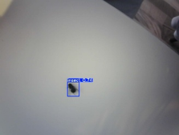
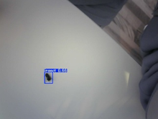
0.68

AI Capability Boundaries
During the specimen experiments, an observation emerged that was completely consistent with the offline validation results obtained during Phase 1.

Although the system could reliably detect butterfly targets, the detection bounding box consistently failed to cover the complete outline of large butterfly specimens.

Instead, detections were concentrated around:
- Wing roots;
- Wing edges;
- Partial body regions;
- Texture-rich feature regions.
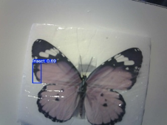
Rather than covering the entire insect.

This phenomenon appeared consistently in:
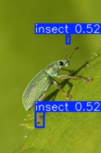
- Phase 1 AI validation;
- All butterfly detection experiments conducted during this phase.
Phase 1 Detection Example

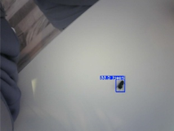
However, when fly specimens were used as targets, the flies could be enclosed by complete detection bounding boxes.

Combined with dataset analysis, it was concluded that the current model exhibits a stronger preference for:
- Small insects;
- Flying insects;
- Insects appearing in natural environments.
As a result, the model demonstrates better adaptability to real fly targets.

Based on the observed experimental behavior, it can also be inferred that the model primarily learned:

Local insect texture features rather than Complete insect contours.

Conclusion
Through real specimen experiments, multi-sample testing, and real insect testing, this phase provided the first systematic evaluation of the actual performance of the current AI model.

Experimental results demonstrated that the system already possesses reliable insect-presence detection capability.

At the same time, the capability boundaries of the model were clearly identified:

The current model primarily relies on local texture features for recognition. Therefore, it is suitable for insect-presence detection, but is not suitable for insect counting or instance-level detection tasks.

Further Optimization of Communication Robustness and Error Recovery Mechanisms

Problem Discovery
During the IWDG testing conducted on May 29, a deficiency in the communication link's recovery capability was identified for the first time.

During the experiment, the IWDG was intentionally triggered to reset the MCU. The system behavior was as follows:
MCU Reset → JPEG Transmission Interrupted → PC Timeout Triggered → Current Session Abnormally Terminated and Stuck

Under normal expectations, after the MCU reset, the communication handshake should be re-established and normal operation should resume.

However, experimental results showed:
MCU Recovered → PC Communication Module Remained in an Abnormal State → Unable to Re-establish a Session → Manual Program Restart Required

This phenomenon indicated that the current communication module lacked the ability to automatically resynchronize after abnormal interruptions.

Further analysis revealed that the root cause originated from the Session management mechanism of the communication module.

Under normal circumstances:
STANDBY → READY → JPEG Transmission → TYPE_REQ → TX_DONE → DONE_ACK → WAIT_STANDBY
The Session lifecycle completes normally.

However, when the MCU unexpectedly resets:
JPEG Transmission → Data Stream Interrupted → Communication Module Continues Waiting for Remaining Data

Since the current Session never reaches a normal termination state, the communication module remains trapped in an abnormal state. Even when the MCU restarts and initiates a new handshake request, the communication module cannot re-enter the synchronization process.

Therefore, it was confirmed that the problem did not originate from flaws in the UART protocol design, nor from the JPEG transmission mechanism itself. Instead, the communication module lacked the capability to terminate abnormal Sessions and rebuild synchronization states.

Recovery Mechanism Optimization
To address the above issue, the recovery mechanism of the communication module was redesigned during this phase.

Newly introduced mechanisms include:
- Session Abort;
- Parser State Recovery;
- Buffer Cleanup;
- WAIT_STANDBY Reconstruction.

The new recovery procedure is as follows:
Transmission Timeout → Session Abort → Clear Image Reassembly Buffer → Clear Parser State → Return to WAIT_STANDBY → Wait for Next MCU Handshake

Through this mechanism, the communication module no longer attempts to continue processing a corrupted Session. Instead, it actively abandons the current Session and returns to the initial synchronization state.

Additionally, the following features were introduced:
- RX_BUFFER_ABORT_LIMIT;
- Automatic abnormal Session termination mechanism.

Design Philosophy
This optimization did not attempt to recover already corrupted image data because, after a JPEG transmission interruption:
- The current image has already lost its business value;
- Forced recovery would increase system complexity;
- New state inconsistencies could potentially be introduced.

Therefore, a design philosophy consistent with the acquisition-side Fail-Fast Cleanup mechanism was adopted:
Detect Exception → Immediately Abandon Current Session → Clean State → Wait for Next Normal Task

That is:
Fail Fast
Recover Clean

Error Injection Mechanism Design and Long-Term Robustness Testing
In Phase 4, the system established an error-injection testing framework based on image-fragment transmission and proposed the Continuous Bad Frames error model.

The core idea of this model is not to enumerate every possible real-world failure source. Instead, various practical issues are abstracted into a unified model in which:
The receiver continuously receives unusable data for a period of time.

The following real-world problems are therefore treated as equivalent manifestations of the same abstract fault:
- Camera abnormalities;
- JPEG generation failures;
- UART packet loss;
- UART jitter;
- Fragment corruption;
- Data loss.
However, the validation target in Phase 4 was primarily the communication module itself.

By Phase 8, the system had already formed a complete closed loop:
STM32H743 → OV2640 Capture → JPEG Generation → UART Transmission → PC Reception → YOLO Inference → MCU Feedback

Therefore, it became necessary to re-evaluate whether the robustness mechanisms established previously remained effective within the final integrated system.

Error Sender Error-Injection Framework Design
To conduct system-level robustness testing, an independent error-injection tool was designed and implemented during this phase:
error_sender.py

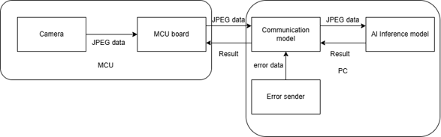
This tool was developed by extending the Sender → Communication Module validation architecture established in Phase 4.

During system operation:
- The MCU operates according to the actual periodic system;
- The camera acquires images normally;
- JPEG data is transmitted normally through UART;
- The AI inference pipeline remains unchanged.
Meanwhile, Error Sender continuously injects corrupted data into the Communication Module through an independent TCP channel.

Within the Communication Module, the existing ENABLE_TCP_INJECT interface was retained, allowing injected data to be merged into the normal reception workflow.

Consequently, all injected data passes through:
try_parse_frame() → Image Fragment Reassembly → Session State Machine → Timeout Cleanup → Session Abort → Next-Cycle Recovery Logic

This architecture allows direct observation of system behavior under continuous abnormal input conditions.

To prevent errors from always occurring at fixed time points, the following configuration was adopted:
- period = 13 s / 17 s
- jitter = ±2 s

By introducing non-integer periodic offsets relative to the MCU execution cycle and applying random timing jitter, error windows gradually cover different Session phases rather than remaining restricted to fixed execution points.

This significantly improves testing coverage.

Long-Term Error Injection Testing
The first round of testing lasted approximately 10 minutes.

During this period, dozens of error windows were injected.

Typical errors included:
- CRC errors;
- LEN abnormalities;
- EOF abnormalities;
- Random noise interference.

Despite these conditions, the system continued operating normally and exhibited no loss of state control.

Subsequently, a second round of testing was conducted.

The test duration was extended to 30 minutes, and the error-injection period was adjusted from 13 seconds to 17 seconds, allowing error windows to cover a wider range of Session phases.

As testing progressed, more complex abnormal conditions began to appear:
- Image reassembly failures;
- Session Abort events;
- Image Assembly Timeout events;
- Chunk semantic abnormalities;
- Residual data from previous Sessions entering subsequent handshake stages.
Nevertheless, the system remained capable of automatically recovering normal operation.

The test lasted approximately one hour and accumulated hundreds of error-injection windows.

During this period, the following abnormal conditions were repeatedly triggered:
- CRC_FAIL;
- BAD_LEN;
- BAD_EOF;
- Image Timeout;
- Session Abort;
- Chunk semantic errors;
- Handshake re-synchronization events.

However, none of the following failures occurred:
- Program deadlock;
- MCU deadlock;
- Unlimited growth of the receive buffer;
- Long-term retention of corrupted images;
- Permanent Session misalignment;
- Persistent contamination of subsequent Sessions;
- IWDG resets.

The test was ultimately terminated manually.

Analysis of Error Recovery Mechanisms
After completion of testing, log files and source code were jointly analyzed.

The analysis confirmed that system robustness primarily relies on the following six layers of protection:

- Low-Level Frame Parsing and Re-Synchronization Mechanism

When abnormal data enters the receive buffer, the parser actively discards invalid data and searches for a valid Start-of-Frame (SOF).

This prevents the parsing process from becoming permanently blocked.

- Image Reassembly Timeout Cleanup Mechanism

When image fragments cannot be successfully reassembled within a reasonable period of time, the system automatically clears the current image state.

This prevents corrupted image data from remaining in memory indefinitely.

- Chunk Semantic Error Detection Mechanism

For data fragments whose CRC values are valid but whose semantic contents are incorrect, the system actively terminates the current Session.

- Session Abort Mechanism

When an abnormal condition occurs, the system actively clears:
- Image buffers;
- Session states;
- Residual serial-port data.
This prevents abnormal states from continuing to propagate.

- WAIT_STANDBY Re-Synchronization Mechanism

System re-synchronization is not based on a particular byte following a corrupted frame.

Instead, synchronization is re-established through the STANDBY handshake of the next Session, ensuring that Session boundaries are reconstructed correctly.

- Finite Waiting Mechanism During the TX_DONE Stage

Timeout control and alternative handshake detection mechanisms prevent the system from remaining indefinitely in the Session termination stage.

Conclusion
This phase completed the final robustness validation of the system.

Through the Error Sender error-injection framework and long-term Continuous Bad Frames testing, the applicability of the Continuous Bad Frames model established in Phase 4 was successfully validated within the final integrated system.

Experimental results demonstrated that even under continuous error-injection conditions, the system was able to maintain:
- Error isolation;
- Clear state boundaries;
- Automatic Session recovery;
- Normal execution of subsequent tasks.

The final system successfully passed:
- 10-minute continuous error-injection testing;
- 30-minute continuous error-injection testing;
- hour continuous error-injection testing.

These results demonstrate that the current communication architecture, recovery framework, and state-machine design possess long-term operational stability.

At this point, the robustness validation work of Phase 8 was successfully completed, and the entire project achieved its intended design objectives and became suitable for archival preservation.

Phase Summary
Phase 8 represents the final development phase of this project and serves as a critical stage in the evolution of the Embedded AI Insect Detection System from functional validation to engineering validation.

During the previous phases, the system had progressively completed:
- AI model training and validation;
- Communication protocol design and implementation;
- STM32H743 platform migration;
- OV2640 camera integration;
- JPEG image acquisition and transmission;
- Establishment of the AI inference closed loop.

Therefore, the primary objective of this phase was no longer the implementation of new core functions, but rather the construction of the final system form, clarification of capability boundaries, and validation of long-term operational stability.

First, this phase completed the development of the periodic capture system. The system was upgraded from the original button-triggered mode to an autonomous periodic operating mode, achieving the transition from a manually triggered validation system to an autonomous operating system. At the same time, the Pending/Busy scheduling mechanism resolved task-overlap issues within the periodic system, while the LED runtime indication framework and IWDG hardware protection mechanism enabled long-term unattended operation.

Second, a complete feedback mechanism was established. For the first time, the system achieved the complete closed loop:
Camera Capture → AI Inference → MCU Result Acquisition → LED/Buzzer Feedback

This allowed AI recognition results to directly influence device-side feedback behavior, forming a complete human–machine interaction chain.

Regarding image acquisition and AI validation, this phase completed real insect specimen experiments, multi-sample testing, and real insect testing while also establishing a standardized operating environment. Experimental results demonstrated that the system can reliably perform insect-presence detection. At the same time, the capability boundaries of the current model were clarified. The model primarily relies on local texture features for recognition and is therefore more suitable for insect-presence detection than for insect counting or instance-level detection tasks. Through these experiments, the operational boundaries of the system were clearly defined.

In terms of robustness enhancement, this phase further improved the recovery framework on the communication side by introducing mechanisms such as Session Abort, Parser Reset, and WAIT_STANDBY re-synchronization, addressing the previously missing automatic recovery capability following abnormal communication interruptions. Subsequently, based on the Continuous Bad Frames model proposed in Phase 4, the Error Sender error-injection framework was developed and used to conduct continuous error-injection tests lasting 10 minutes, 30 minutes, and 1 hour. Experimental results demonstrated that the system maintained state correctness and recovery capability under continuous abnormal input conditions, without exhibiting deadlocks, state contamination, or long-term synchronization failures.

Based on the results of all experiments, it can be confirmed that the system has successfully completed validation of the following engineering closed loop:
STM32H743 → OV2640 Image Acquisition → JPEG Generation → UART Transmission → YOLO Inference → MCU Feedback → Abnormality Detection → Automatic Recovery

At the same time, the system now possesses:
- Autonomous operation capability;
- Target detection capability;
- Feedback interaction capability;
- Error recovery capability;
- Long-term stable operation capability.

At this point, all planned development objectives of the project have been successfully completed.

The system has successfully passed real-target validation, long-term operation validation, and continuous error-injection validation, achieving the expected design objectives and meeting the requirements for project archival preservation.

Future work will gradually shift toward thesis preparation, result archiving, and project demonstration activities.

